National University of Computer and Emerging Sciences



Lab 03

COAL LAB

|  |  |
| --- | --- |
| Name | Muhammad Zain |
| Roll No. | 19F-0228 |
| Lab Instructors | Mr Abuzar Ghfari |
| Semester | Fall 2020 |

Problem 1:

# **Source Code:**

*; Author: M Zain*

; Program Name: Task1

; Date:10/22/2020

INCLUDE Irvine32.inc

.data

array DQ 33,44,55,66,77,88,99

.code

main PROC

mov eax ,TYPE array

mov ebx ,SIZEOF array

mov ecx, LENGTHOF array

exit

main ENDP

END main

# **Snip:**

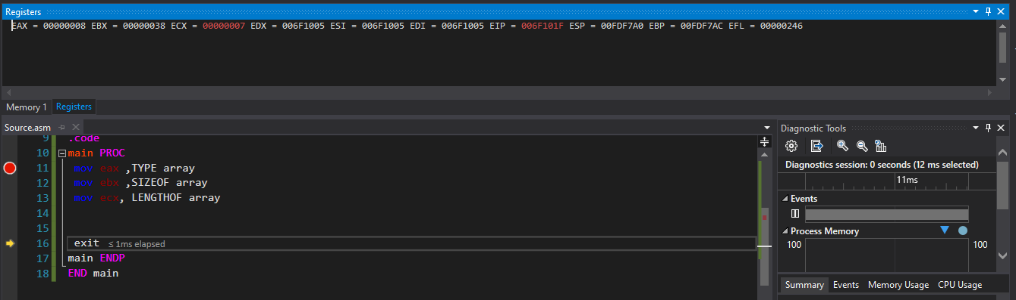

Problem 2:

# **Source Code:**

*; Author: M Zain*

; Program Name: Task2

; Date:10/22/2020

INCLUDE Irvine32.inc

.data

prompt byte "Please Enter your name: ", 0

nameBuffer byte 50 dup(?)

Count dword ?

.code

main PROC

mov edx, offset prompt

call WriteString

mov edx, offset nameBuffer

mov ecx, sizeof nameBuffer

call ReadString

mov Count, eax

call WaitMsg

exit

main ENDP

END MAIN

# **Snip:**

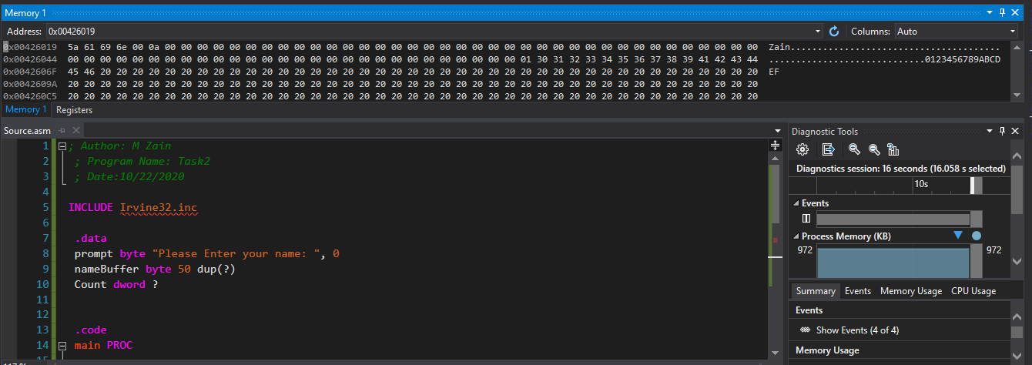

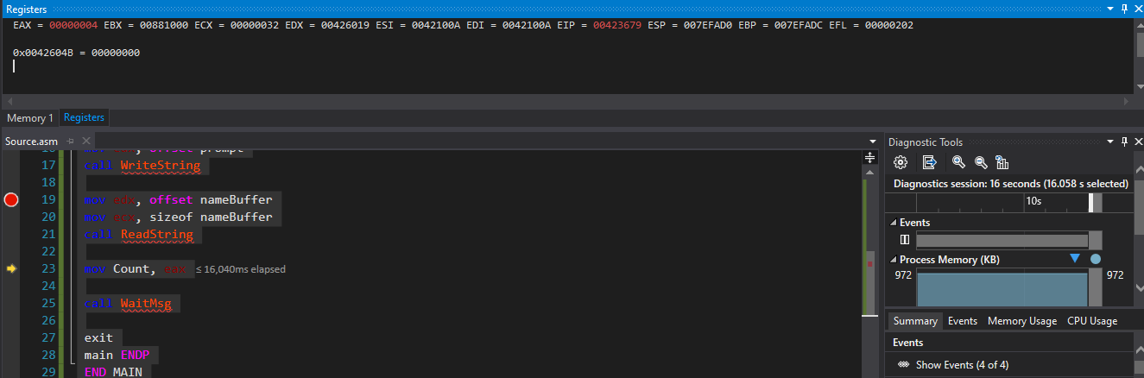

Problem 3:

# **Source Code:**

*; Author: M Zain*

; Program Name: Task3

; Date:10/22/2020

INCLUDE Irvine32.inc

.data

string1 byte "Please Enter your name: ", 0

string2 byte "Mr./Miss ",0

string3 byte " is learing assembly Language",0

string4 byte "Number of Character typed = ",0

nameBuffer byte 50 dup(?)

Count dword ?

.code

main PROC

mov edx, offset string1

call WriteString

mov edx, offset nameBuffer

mov ecx, sizeof nameBuffer

call ReadString

mov Count, ecx

mov edx, offset string2

call WriteString

mov edx, offset nameBuffer

call WriteString

mov edx, offset string3

call WriteString

call Crlf

mov edx, offset string4

call WriteString

mov edx,offset Count

call Writedec

call Crlf

call WaitMsg

exit

main ENDP

END main

# **Snip:**

Problem 4:

# **Source Code:**

*; Author: M Zain*

; Program Name: Task4

; Date:10/22/2020

INCLUDE Irvine32.inc

.data

var1 byte "Enter Value of X: ", 0

var2 byte "Enter Value of Y: ",0

T1 dWord ?

T2 dWord ?

Yequal dWord ?

.code

main PROC

mov edx, offset var1

call WriteString

call ReadDec

mov T1,eax

mov edx, offset var2

call WriteString

call ReadDec

mov T2, eax

mov eax,T1

imul eax, 5

add eax,T2

mov Yequal, eax

call writedec

call crlf

call WaitMsg

exit

main ENDP

END main

# **Snip:**

